Task 1:Working with SNS

ss1:sns console

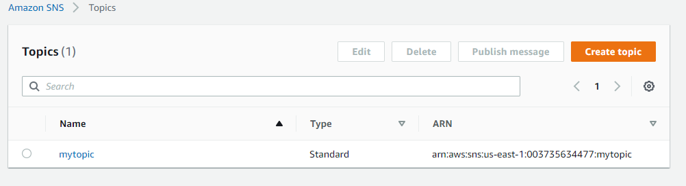

ss2:your inbox with the published message

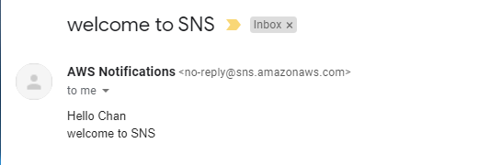

Task 2 :Working with SQS

ss1: sqs console

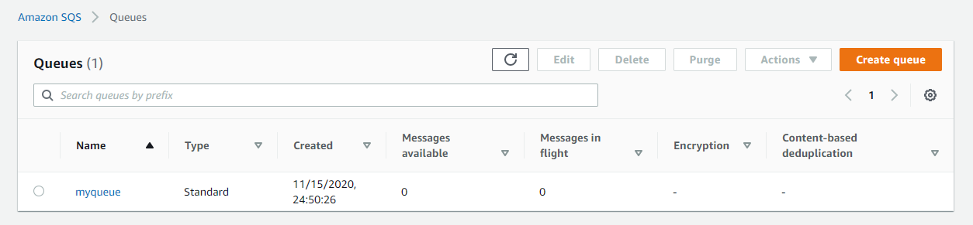

ss2: poll for messages and display message window

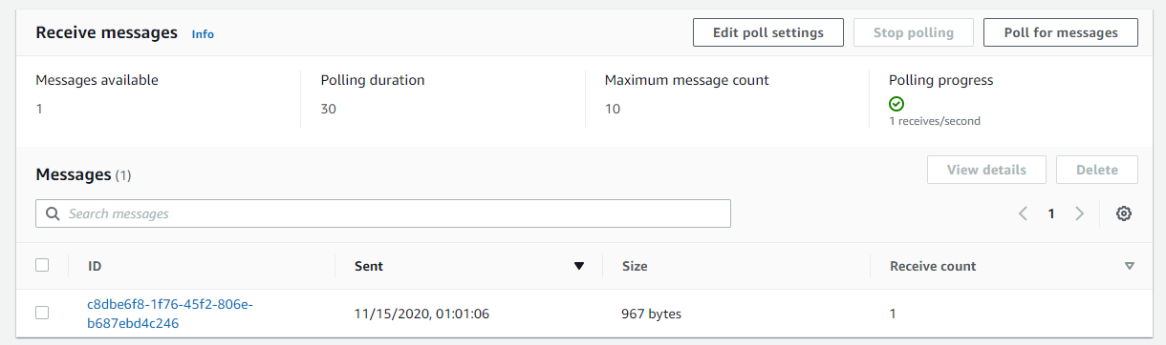

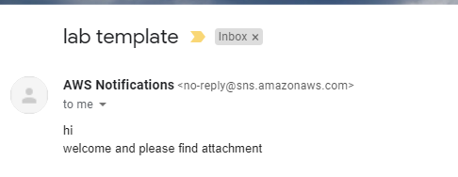

Task 3:Working with SES

ss1:inbox mail verification

